Back up MySQL database web2019

1. First step we need to Download and Install software mysql-backup-pro-trial.exe.
2. 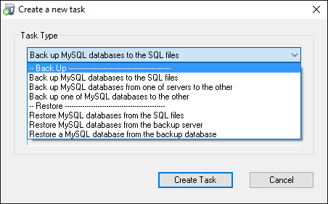Startup program
3. 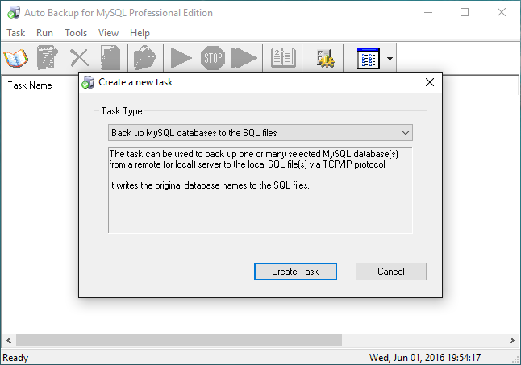Create task
4. Write name of task

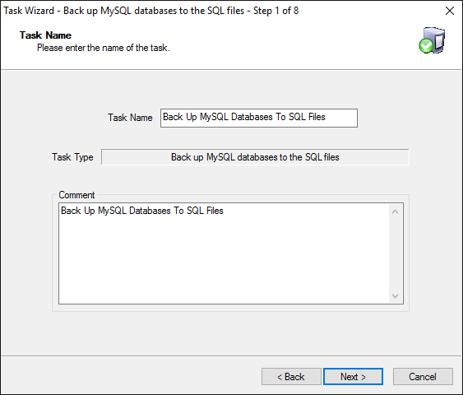

1. Connect to MySQL server
2. Choose database for back up
3. Click SQL file for back up to SQL file
4. Back up file setting then click ok
5. Compression options
6. Buffer mode
7. Choose time for back up
8. View task information and finish
9. You will see you SQL file in C:\Users\sokkun.norn\AppData\Roaming\SwordSky Software\MySQL\Auto Backup\Data\Task 2\

